**CHAPTER 1**

**INTRODUCTION**

Database is a collection of data and Management System is a set of programs to store and retrieve those data. Based on this one can **define** DBMS as a collection of inter-related data and set of programs to store & access those data in an easy and effective manner.

**1.1 What is the need of DBMS?**  
 Database systems are basically developed for large amount of data. When dealing with huge amount of data, there are two things that require optimization: Storage of data and retrieval of data.

**Storage:** According to the principles of database systems, the data is stored in such a way that it acquires lot less space as the redundant data (duplicate data) has been removed before storage. Let’s take a layman example to understand this. In a banking system, suppose a customer is having two accounts, one is saving account and another is salary account. Let’s say bank stores saving account data at one place (these places are called tables we will learn them later) and salary account data at another place, in that case if the customer information such as customer name, address etc. are stored at both places then this is just a wastage of storage (redundancy/ duplication of data), to organize the data in a better way the information should be stored at one place and both the accounts should be linked to that information somehow. The same thing we achieve in DBMS.

**Fast Retrieval of data**: Along with storing the data in an optimized and systematic manner, it is also important that we retrieve the data quickly when needed. Database systems ensure that the data is retrieved as quickly as possible.

The choice of a database product is often influenced by factors such as:

* the computing platform (i.e., hardware, operating system)
* the volume of data to be managed
* the number of transactions required per second
* support for heterogeneous and/or distributed computing
* cost
* vendor support

**1.2Design and Modeling:**

The first task of a database designer is to produce a [conceptual data model](https://en.wikipedia.org/wiki/Conceptual_data_model) that reflects the structure of the information to be held in the database. A common approach to this is to develop an entity-relationship model, often with the aid of drawing tools. Another popular approach is the [Unified Modeling Language](https://en.wikipedia.org/wiki/Unified_Modeling_Language). A successful data model will accurately reflect the possible state of the external world being modeled: for example, if people can have more than one phone , it will allow this information to be captured.



**Figure 1.1: Simplified database system environment**

**1.3 Objective**

The main objective of our project is to change the current manual system to a computerized system to be time efficient & less work oriented by managing the STUDENTS & TEACHER through an interactive software in an hierarchical manner.

**1.4 Problem Statement**

It is a very tedious and time-consuming process of storing the data and managing the data of students through traditional method.

Such as tracking attendance, uploading marks or adding students, teachers, etc. in a college’s or school’s file or record.

If we use a software application for the same it will be easy to maintain the record of the students and accessing it. It will increase the time efficiency and reduce the human effort.

**1.5 Scope of report**

The essential framework of this report would be to elaborate the design of E-R Diagram, Schema Diagram and to display how the modules of the program will work in order to achieve the automation.

.

**CHAPTER 2**

**System and software requirements and specifications**

This chapter explains about System and Software Requirements and Specification.

**2.1 FUNCTIONAL REQUIREMENTS**

A description of the facility or feature required. Functional requirements deal with what the system should do or provide for users. They include description of the required functions, outlines of associated reports or online queries, and details of data to be held in the system.

**2.1.1 Interface Requirements:**

* The system should provide an option for Student to Login.
* The system should give option for admin login.
* The system should provide an option for Teacher to Login.
* The system should provide the Student to view their marks and attendance.
* The system should provide the Teacher to mark their respective class’s students attendance and upload their marks.

**2.2 NON-FUNCTIONAL REQUIREMENTS:**

Non-functional requirements define the overall qualities or attributes of the resulting system.

***2.2.*1 Usability**

Usability is the ease with which a teacher can insert, update, manipulate and manage the student’s academic data and the student can view his/her data.

**2.2.2 Security**

Security requirements are included in a system to ensure:

* The data related to a entity can’t be modified being in the same level as the data.

i.e. Only an H.O.D can change the data related to a teacher; a teacher can update the details related to the student.

**2.2.3 Reliability**

Reliability is the ability of a system to perform its required functions under stated conditions for a specific period of time. Constraints on the run-time behavior of the system can be considered under two separate headings:

* Availability: is the system available for service when requested by end-users.
* Failure rate: how often does the system fail to deliver the service as expected by end-users.

**2.2.4*.* Efficiency**

The comparison of what is actually produced or performed with what can be achieved with the same consumption of Clouds (money, time, labor, etc.). It is an important Factor in Determination of Productivity.

**2.3 Software Requirements**

Programming language : JAVA, MYSQL

Operating system :ANY OS (Recommended**:** Windows10,

Windows Vista, Windows XP)

Application required : Any browser application & Xampp

Coding language : Java

**2.4 Hardware Requirements**

C.P.U : Pentium IV 2.4 GHz or above

Memory (Primary) : 512 MB, 1 GB or above

Hard Disk : 40 GB, 80GB, 160GB or above

Monitor : 15 VGA color

**CHAPTER: 3**

**SYSTEM DESIGN**

This chapter of the report describes the structure of the project, followed by Entity Relationship Diagram, Schema Diagram and the table structures.

**3.1 ER Diagram with relationships and cardinality ratio**

An entity relationship model, also called an entity-relationship (ER) diagram*,* is a graphical representation of entities and their relationships to each other, typically used in computing in regard to the organization of [data](http://www.webopedia.com/TERM/D/data.html) within [databases](http://www.webopedia.com/TERM/D/database.html) or information systems. An entity is a piece of data-an [object](http://www.webopedia.com/TERM/O/object.html) or concept about which data is stored.

The cardinality or fundamental principle of one data aspect with respect to another is a critical feature. The relationship of one to the other must be precise and exact between each other in order to explain how each aspect links together. In simple words Cardinality is a way to define the relationship between two entities.

The following are the notations of the ER diagram:

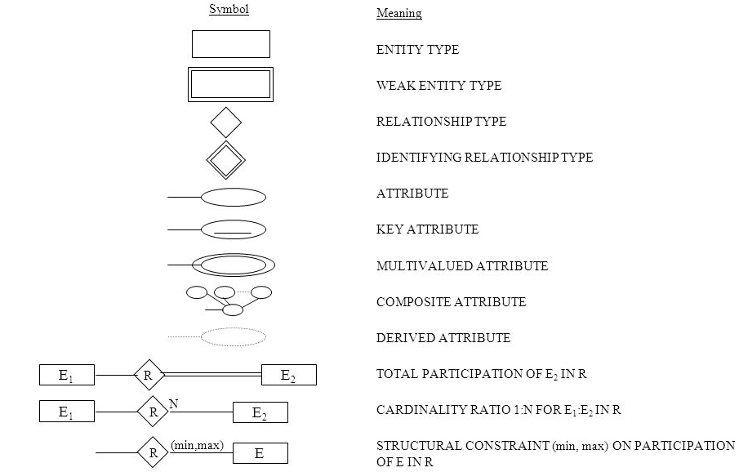

The ER diagram below shows the relationship between the many tables that exist in the database for the functioning of E-Store Management System. 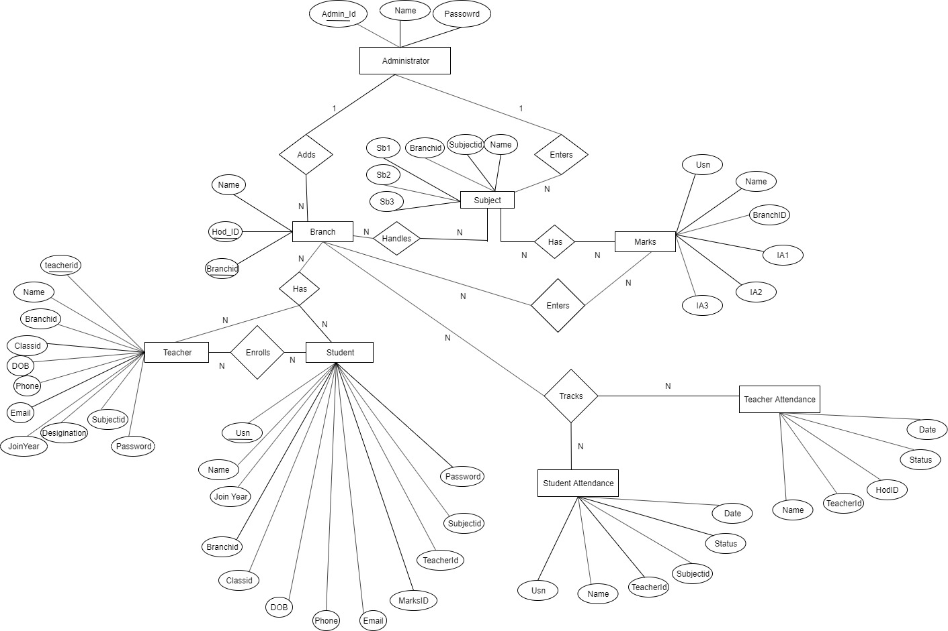

**Fig 3.2: ER Diagram of College Department Management System (EMUDS)**

**3.3 Schema Diagram**

In any data model it is important to distinguish between the description of the database and the database itself. The description of a database is called the database schema, which is specified during database design and is not expected to change frequently.

A displayed schema is called a schema diagram. A schema diagram displays only some aspects of a schema, such as the names of record types and data items, and some types of constraints.

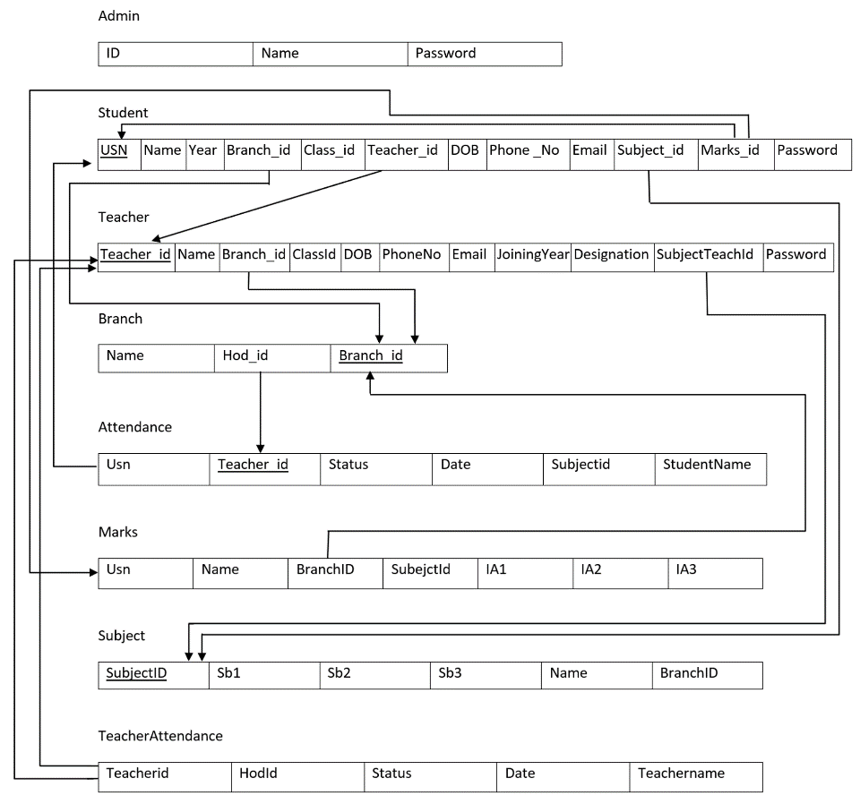

**Fig 3.3: Schema Diagram of College Database Management System (EMUDS)**

**CHAPTER 4**

**FUNCTIONS**

This chapter of the report describes the Functions, packages and modules used in the project:

**4.1 Libraries and Frameworks**

**JAVA**

**Java** is a general-purpose computer-programming language that is concurrent, class-based, object-oriented, and specifically designed to have as few implementation dependencies as possible.

**JAVA SWING**

Swing is a GUI widget toolkit for Java. It is a part of Oracle’s Java Foundation Classes (JFC) – an API for providing a graphical user interface (GUI) for Java programs.

**Java Libraries :**

The Java Class Library(JCL) is a set of dynamically loadable libraries that java applications can call at [run time](https://en.wikipedia.org/wiki/Run_time_(program_lifecycle_phase)). Because the [Java Platform](https://en.wikipedia.org/wiki/Java_Platform) is not dependent on a specific [operating system](https://en.wikipedia.org/wiki/Operating_system), applications cannot rely on any of the platform-native libraries. Instead, the Java Platform provides a comprehensive set of [standard class libraries](https://en.wikipedia.org/wiki/Standard_library), containing the functions common to modern operating systems. There are multiple kinds of library constructs to consider, including:

* + classes
  + interfaces
  + packages
  + classes and interfaces with generic type parameters
* Classes and interfaces are grouped into packages
* packages are named into categories and subcategories, separated by the dot-operator. Examples of packages:
  + java.lang
  + java.util
  + java.util.concurrent
* If a class is inside a package, we can refer to the whole name by referring to the package name, dot-operator, then class name. Examples:
  + java.lang.String
  + java.util.Scanner
* Classes and interfaces can contain:
  + fields (i.e. data variables)
  + methods (i.e. member functions)

**4.2 Functional Modules**

The functional modules included in the project are listed below:

**Insert Module:**

This module provides the functionality of collecting the required data from the designed interface and transmitting it to the appropriate table present in the database designed for this project. If the provided data does not satisfy the given constraints, it must refrain from storing it into the database.

**Update Module:**

This module again has the functionality of collecting the data from the designed interface, but it updates the already existing tuple that matches the provided primary key of the tuple to be updated, by replacing the existing attribute values with the newly collected data. Again, if the newly provided data does not satisfy the given constraints, it must refrain from updating the corresponding tuple.

**Delete Module:**

The delete counterpart is loaded with the ability to delete a single or multiple records from the table. It searches for the tuple, in the query specified table, based on the provided value

for an attribute. Admin can delete in the interface, based on which delete module searches for the record corresponding to that provided attribute value and deletes the record.

**Retrieve Module:**

The retrieve module has a basic functionality of accessing the entire specified table from the database and displays it.

**Trigger:**

A database trigger is procedural code that is automatically executed in response to certain events on a particular table in a database. The trigger is mostly used for maintaining the integrity of the information on the database.

**Stored Procedure:**

A stored procedure is a subroutine available to connected relational database management system. Stored procedure must be called or invoked, as they are sets of SQL and programming commands that perform very specific functions.

**Special feature:**

The special feature of our project is email. When the Student creates gets registered an email will be sent to their email id that registration is successful.

**CHAPTER 5**

**MODULES IN EMUDS (COLLEGE DEPARTMENT MANAGEMENT SYSTEM)**

Objective of EMUDS is to provide a software tool to ease the management of students & teachers by providing a standard and interactive interface for uploading and managing data related to teachers and students and also other functionalities like tracking attendance, updating of details of both teachers and students. It also provides and interface for insertion of students marks through teacher dashboard and a student can see the same updated result of himself through student specific student dashboard. It will considerably reduce the difficulties faced by the existing system and save time, with minimum error and difficulties.

* **Management using Admin Panel.**
* **Teacher Management.**
* **Student Management.**
* **Student Attendance**
* **Uploading Student Marks (Internals)**
* **Updating Student details**
* **Viewing Details (Student & Teacher)**

**Management Using admin Panel**

After Successful login as admin in this system application we have implemented a hierarchical order of entities with admin been on top then HOD. followed by teacher followed by student. Admin Dashboard has access to execute any kind of viewing query on the database and is only accessible to add HOD. to the database.

**Teacher Management**

After successful login in, if the teacher is a HOD. he/she can add new teacher, track attendance of teachers.

**Student Management**

After successful login the teacher can add new student, update student’s details track attendance of students.

**Student Attendance**

The teacher can mark his/her class all students attendance and while displaying the attendance to student he/she can see percentage and status with a detailed attendance view (subject specific).

**Uploading Student Marks (Internals)**

After successful login the teacher can update the marks of students attending his/her subjects and also it will be shown to student with average and status.

**Updating Student Details**

After successful login the teacher can update the details of students of his/her class only and not some other class’s student.

**Viewing Details (Student & Teachers)**

After successful login the frame provided by the application will be completely user specific i.e. Teacher Dashboard frame for Teachers and Student Dashboard frame for Student with the data specific to the individual which he/her can see using interactive tabs.

**CHAPTER 6**

**SNAPSHOTS**

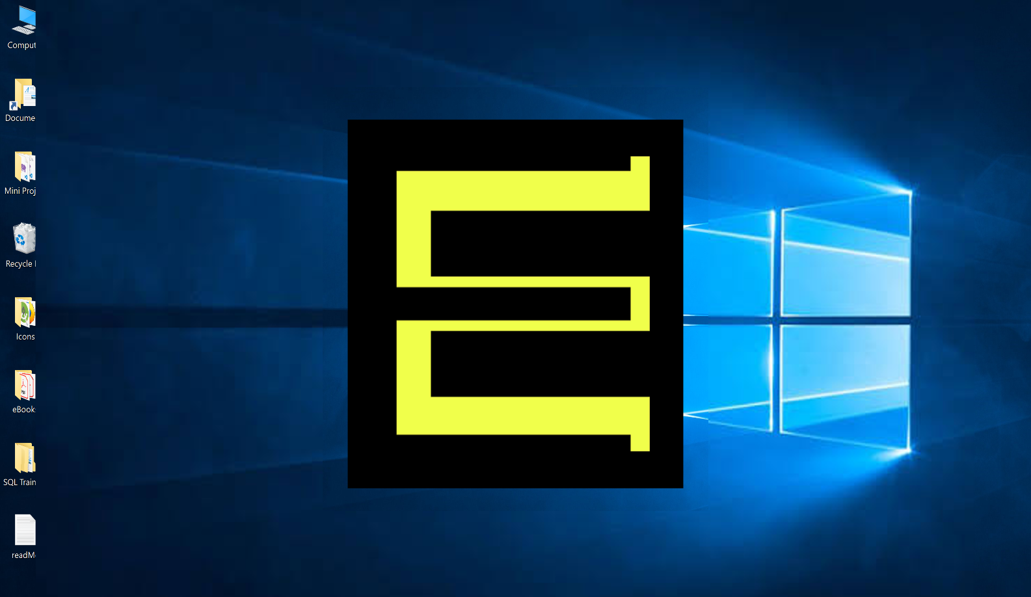

**Snapshot 1:** This is the start logo of the EMUDS application. This logo will load every time the application is executed.

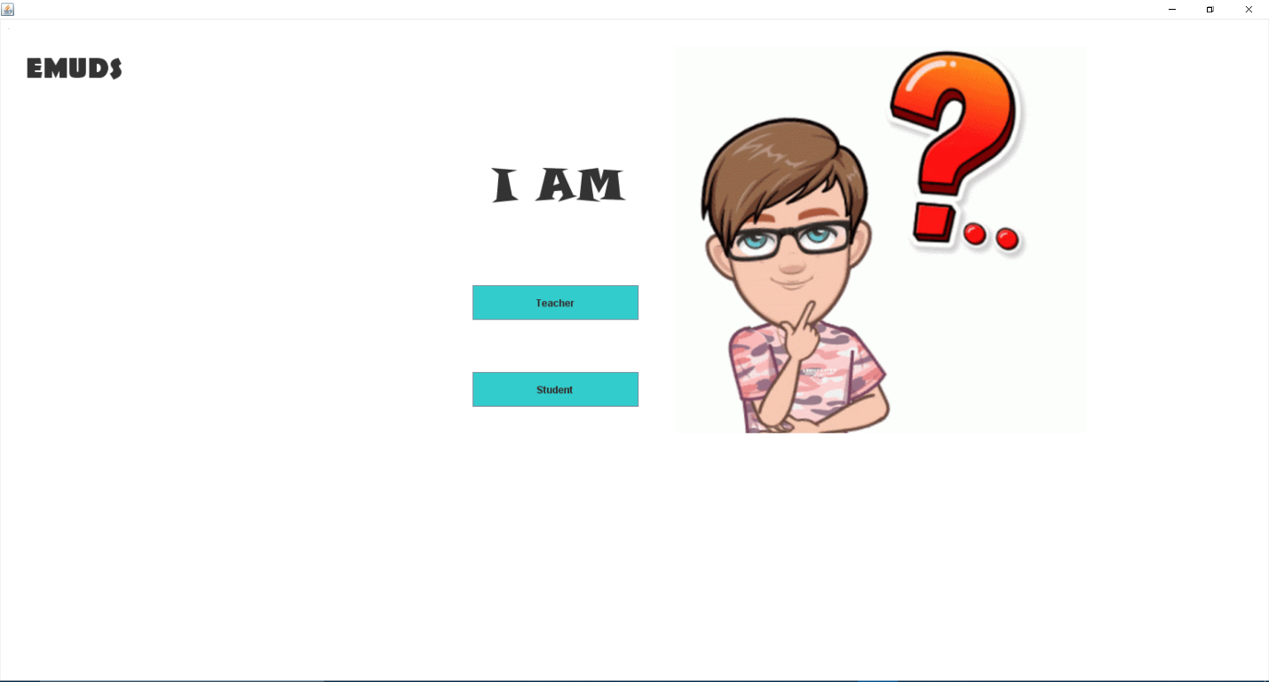

**Snapshot 2**: This is the panel for authentication of teacher, students and admin(Top-Left) where they can login into their respective dashboard using their unique id and password.

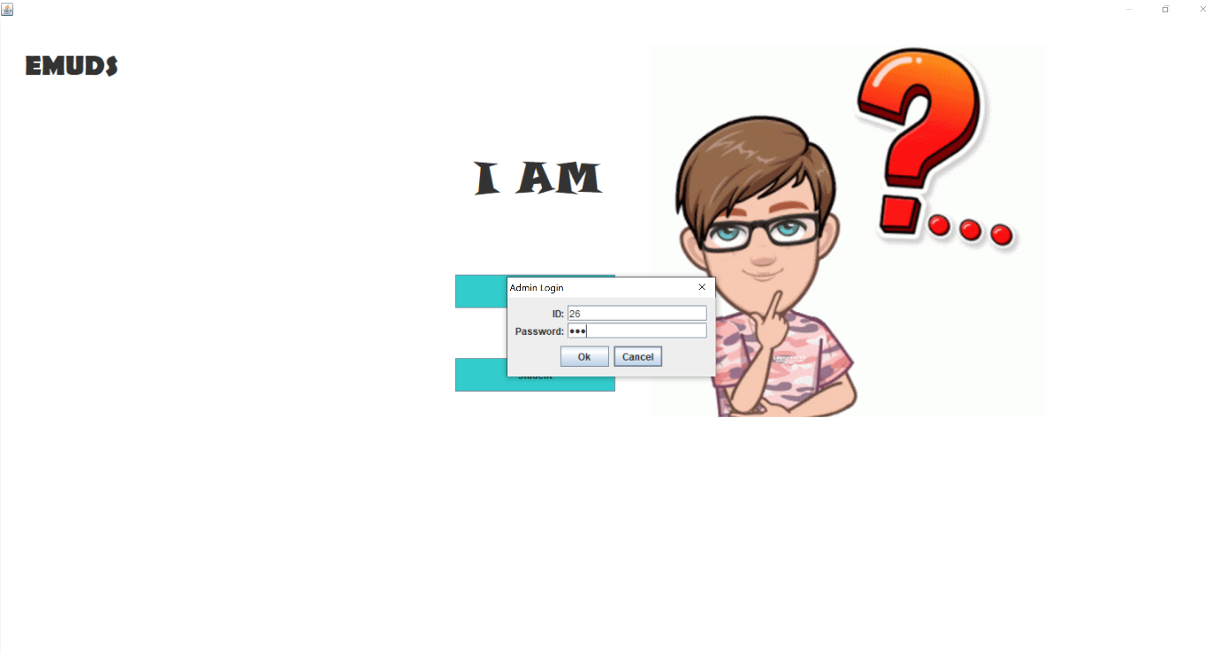

**Snapshot 3**: This popup box is for admin login. After successful login he/she can manage the entire EMUDS application.

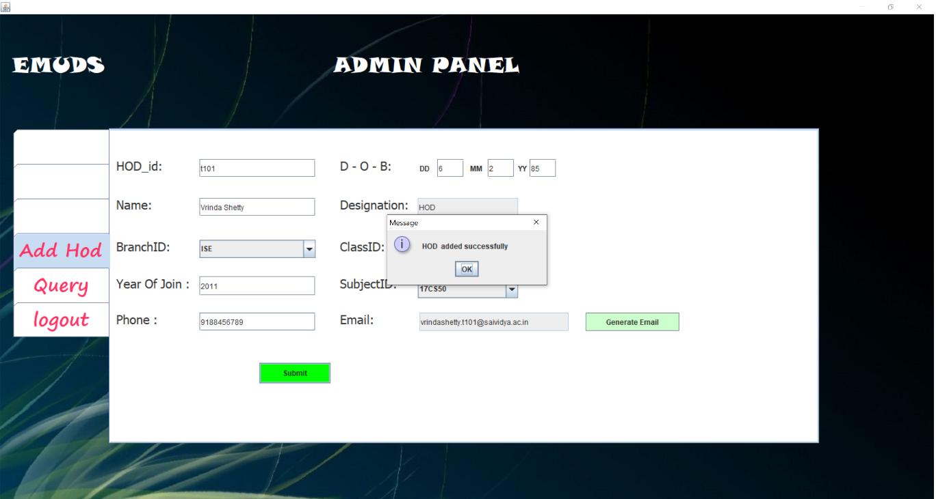

**Snapshot 4:** This is admin dashboard where the admin can add HOD for various branches. Admin can also execute some queries related to EMUDS Database from the QUERY tab (Snapshot 5).

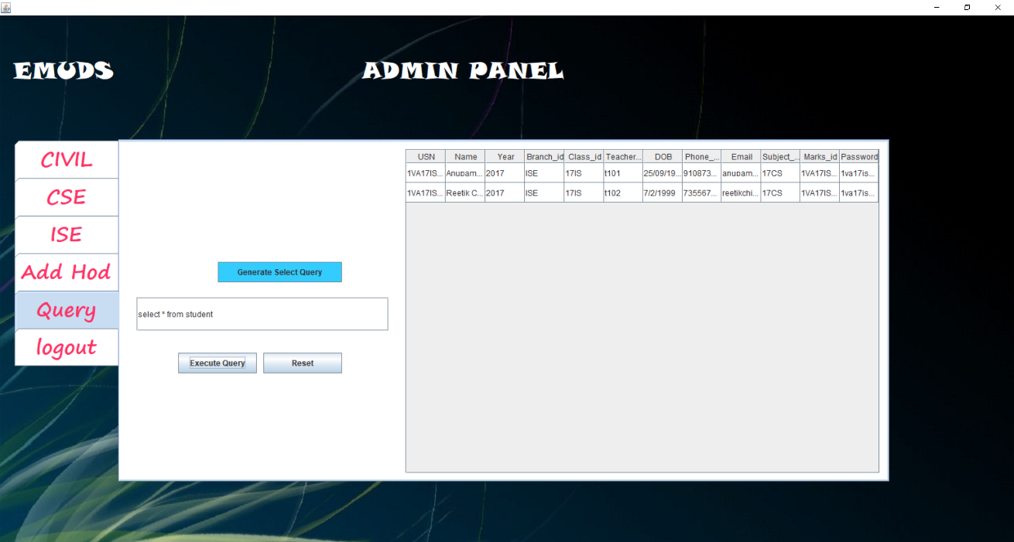

**Snapshot 5:** Admin dashboard Query Tab.

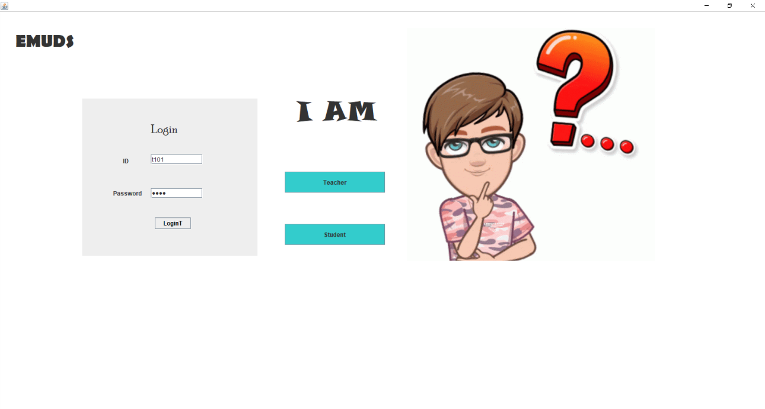

**Snapshot 6:** This is the login panel for teachers where they can login into their dashboard and can track and maintain their students regular activities.

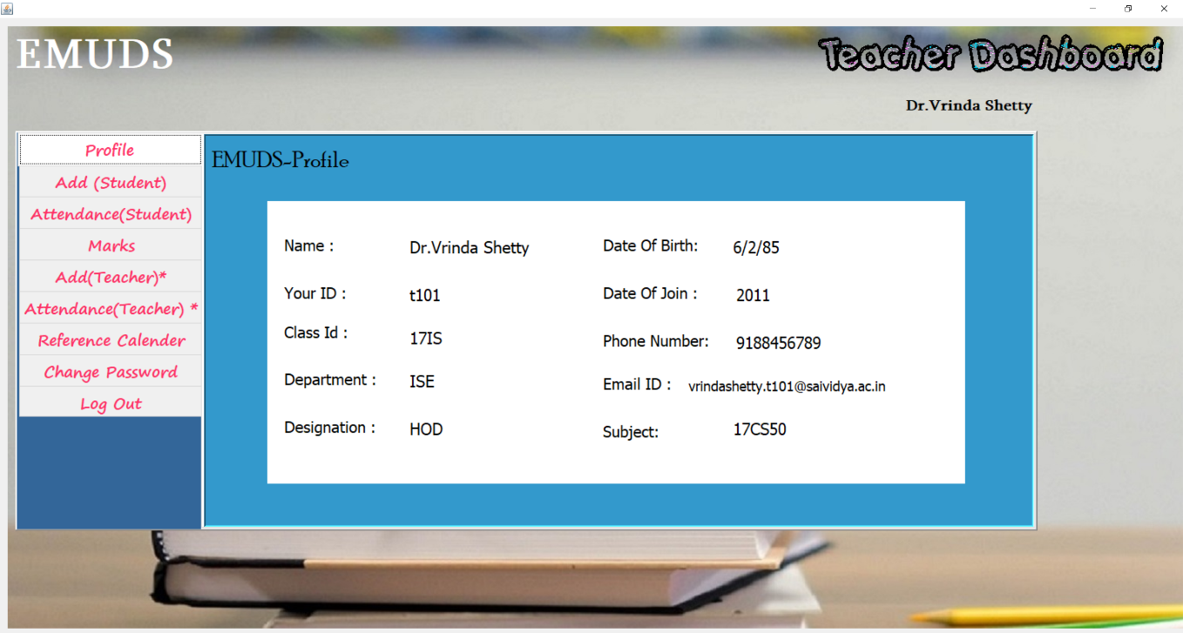

**Snapshot 7:** This is the teacher dashboard (For HOD) where the HOD can insert or update the student details. The HOD can also track the student attendance as well as upload the marks.

HOD can also add the teachers and can track the attendance for the teacher.

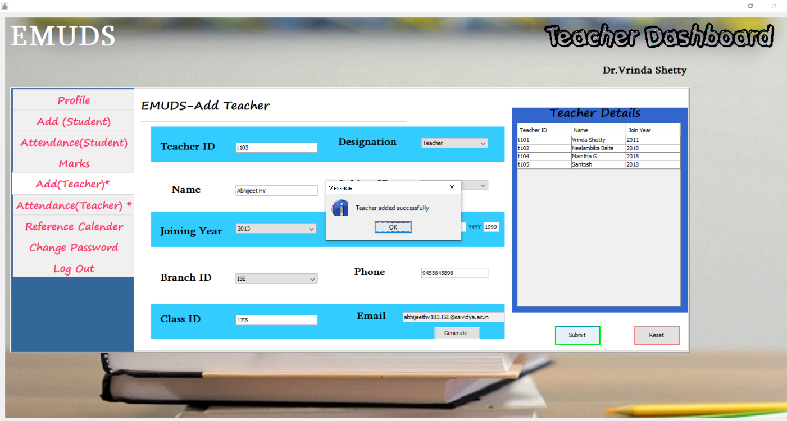

**Snapshot 8:** This is the ADD(Teacher) panel using which the HOD can add the teacher.

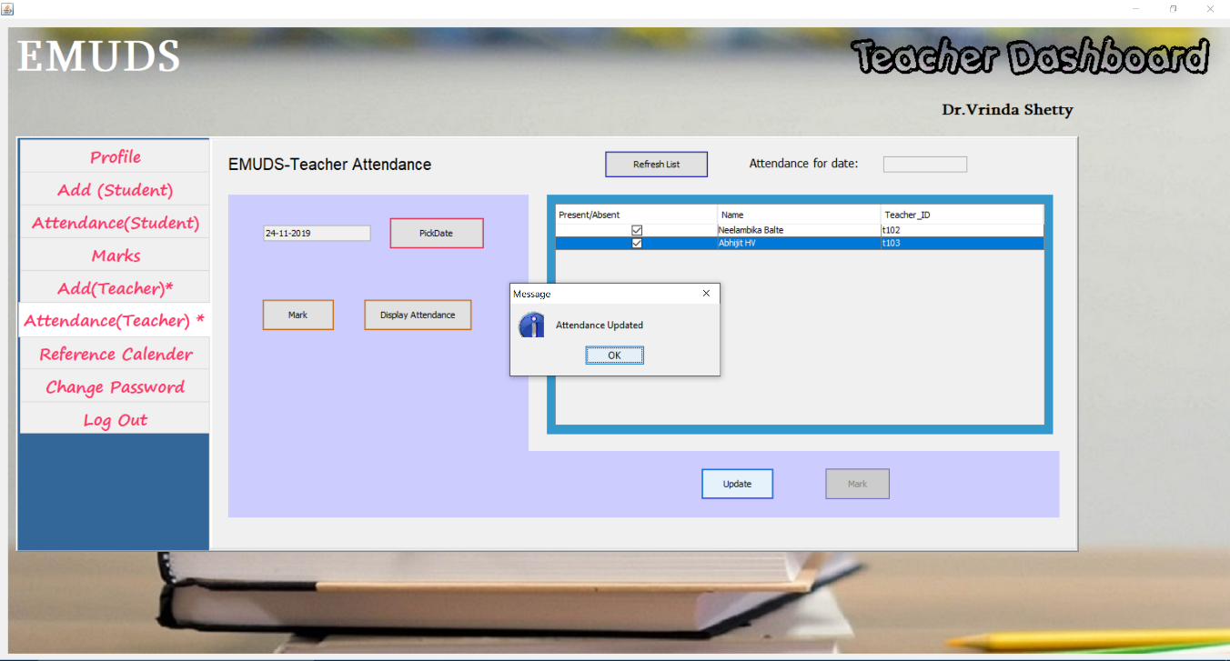

**Snapshot 9:** This is the Attendance panel for teacher where the HOD can track the attendance for the teachers.

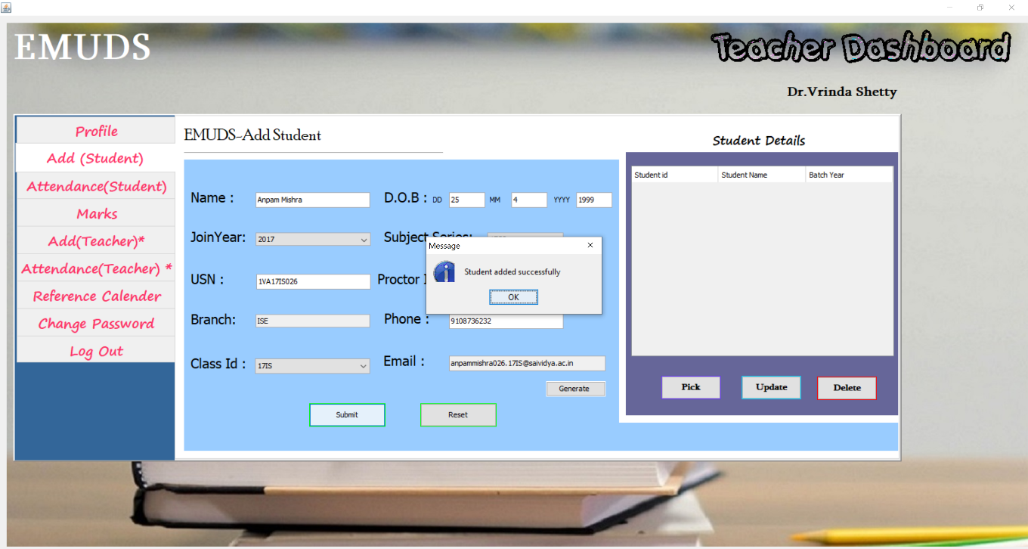

**Snapshot 10**: This panel is for adding student which can be accessed by the teacher.

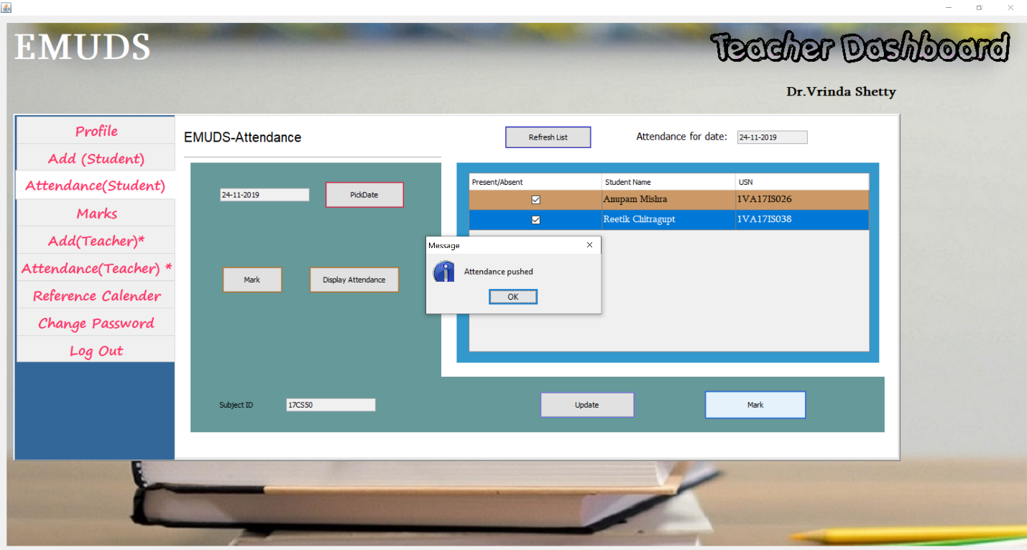

**Snapshot 11**: This panel is for tracking the attendance for the students which can be accessed by the teacher. In this panel the teacher must select the date for attendance and then mark present/absent for the required student and then push the attendance using the mark button.

The teacher can also update the existing attendance.

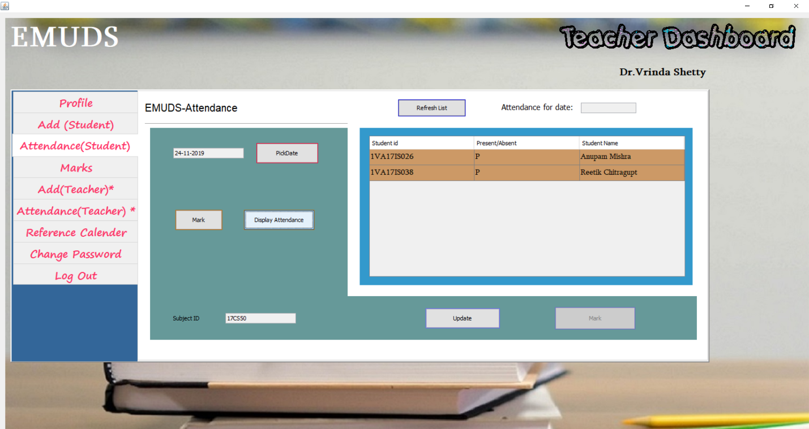

**Snapshot 12**: This panel is for displaying the status of the student attendance for the particular date.

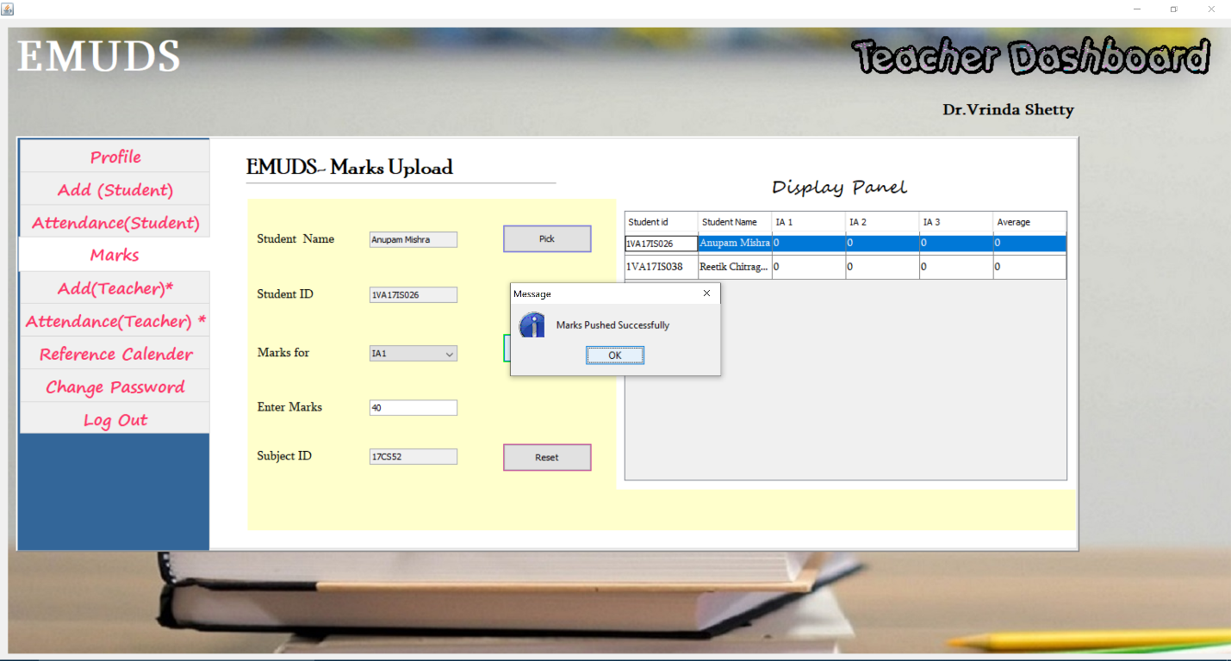

**Snapshot 13**: This panel is for uploading the marks for the student which can be accessed by teacher .

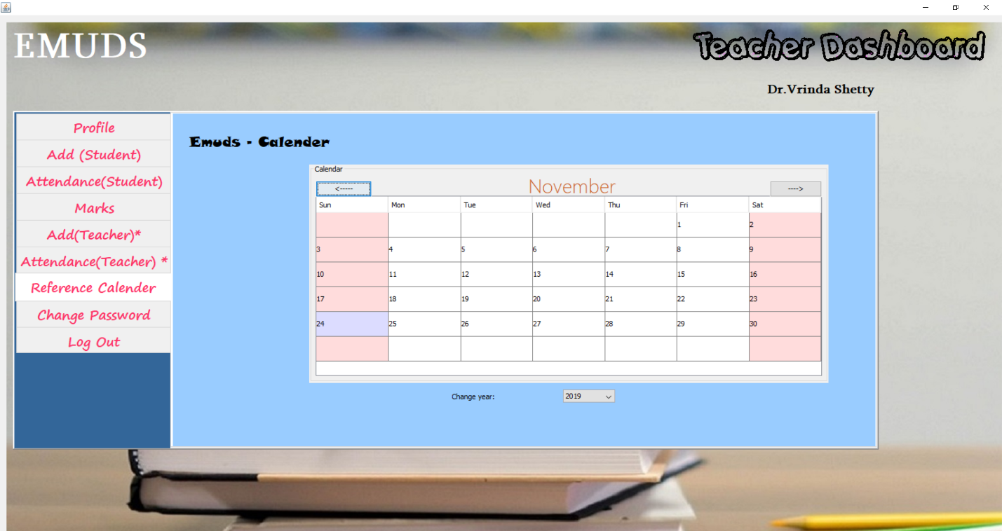

**Snapshot 14**: This panel displays a calendar provided by the EMUDS application for the general usage for the teacher.

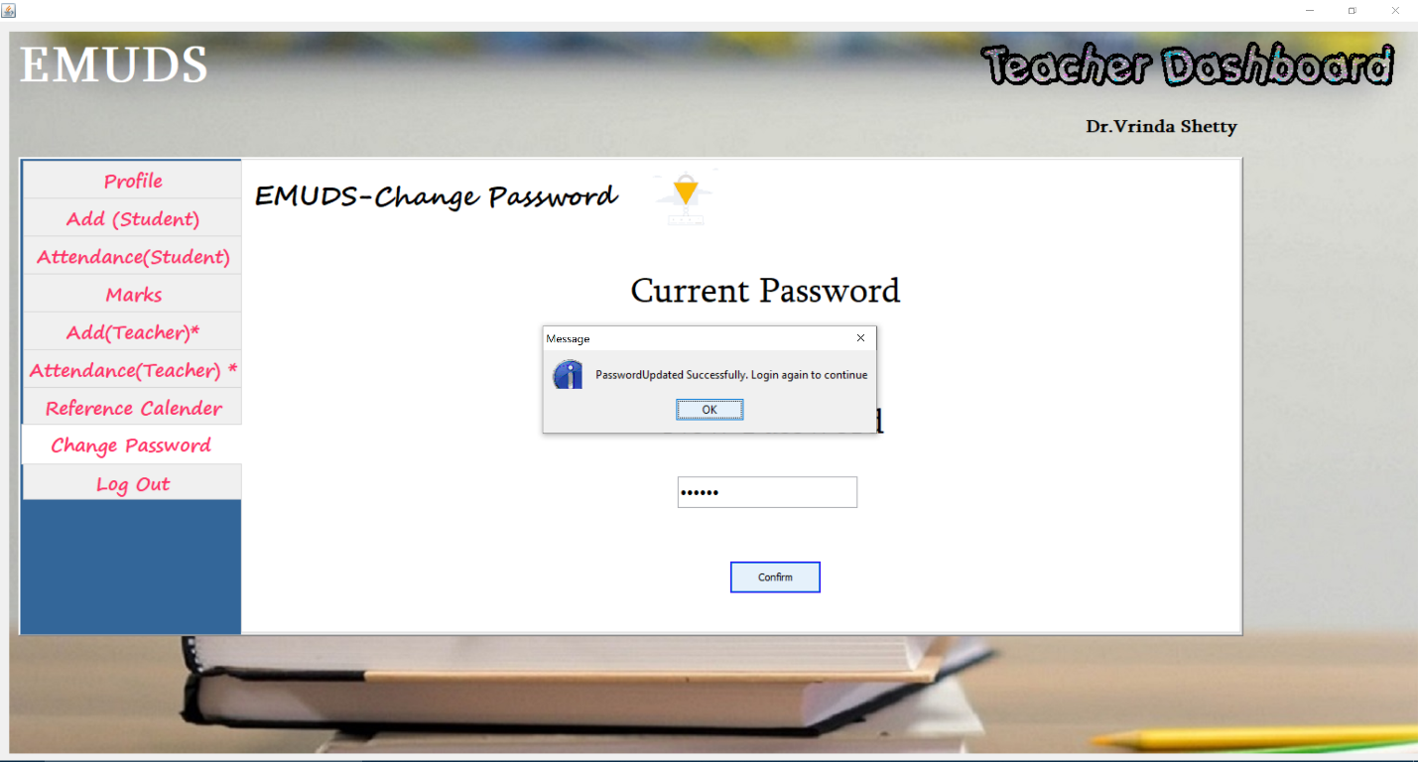

**Snapshot 15**: This panel gives the option to the teacher for changing their password if they want to change.

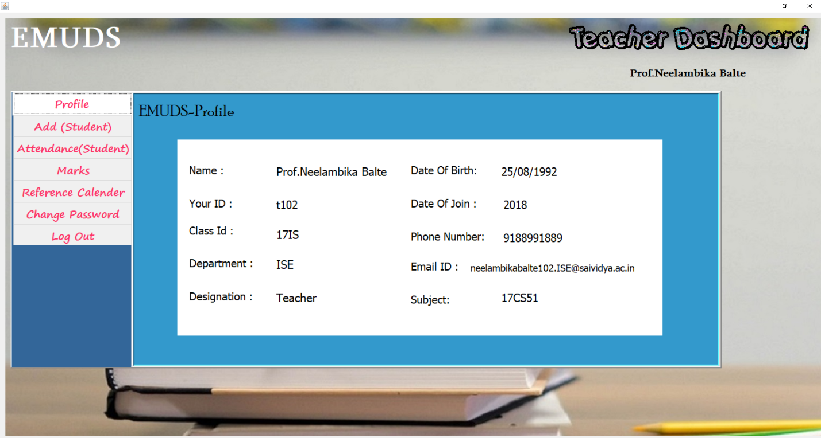

**Snapshot 16**: This panel shows the teacher dashboard which will be displayed if the teacher is not HOD. This panel does not have the feature of adding the teacher or tracking their attendance only HOD has permission for that.

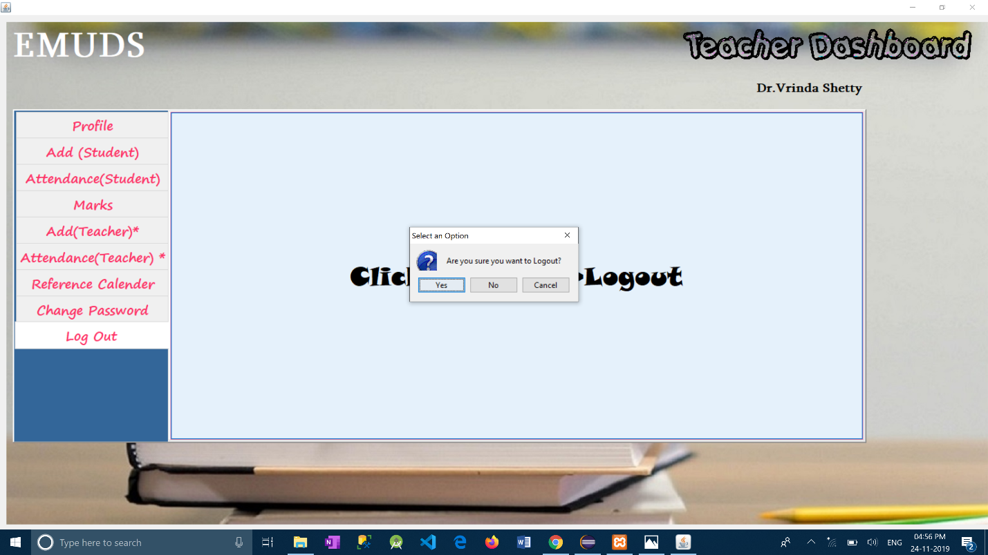

**Snapshot 17**: This panel gives the option to the teacher to logout.

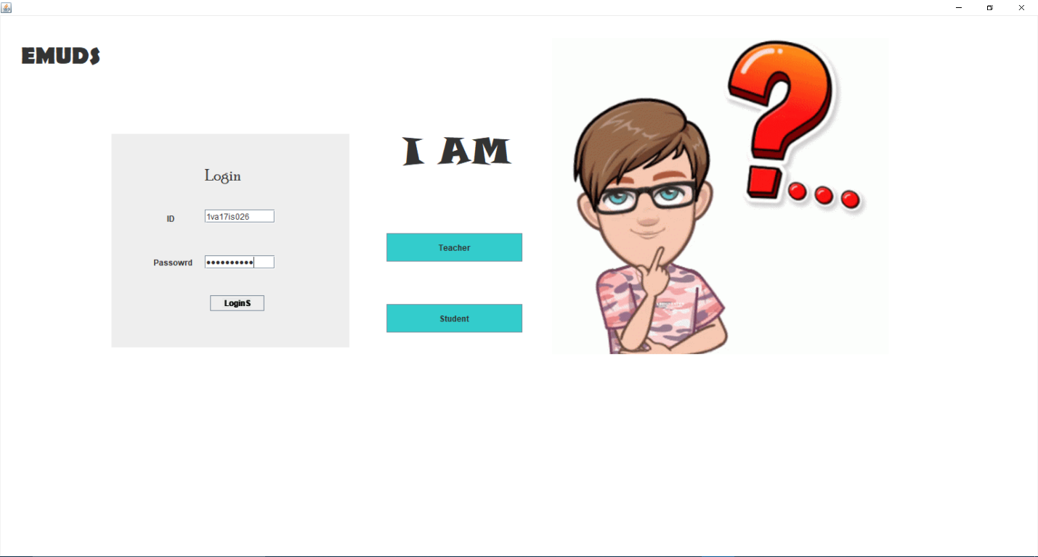

**Snapshot 18**: This panel is for authentication of the students. A student can login into the Student’s dashboard provided by EMUDS using their unique id and password.

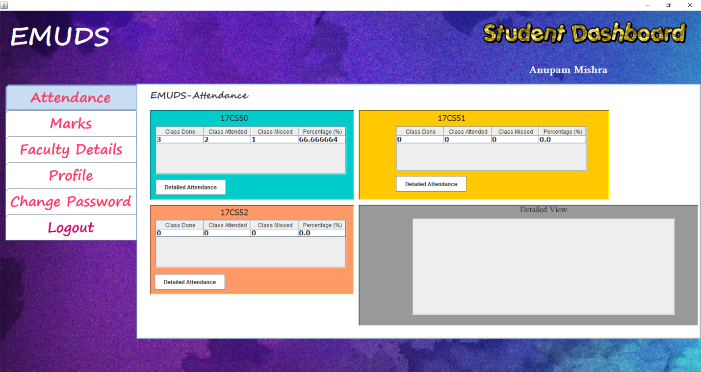

**Snapshot 19**: This panel gives the student a view of their current attendance. Mini-view in the 3 smaller tables and detailed day-to-day attendance in the bottom-right table.

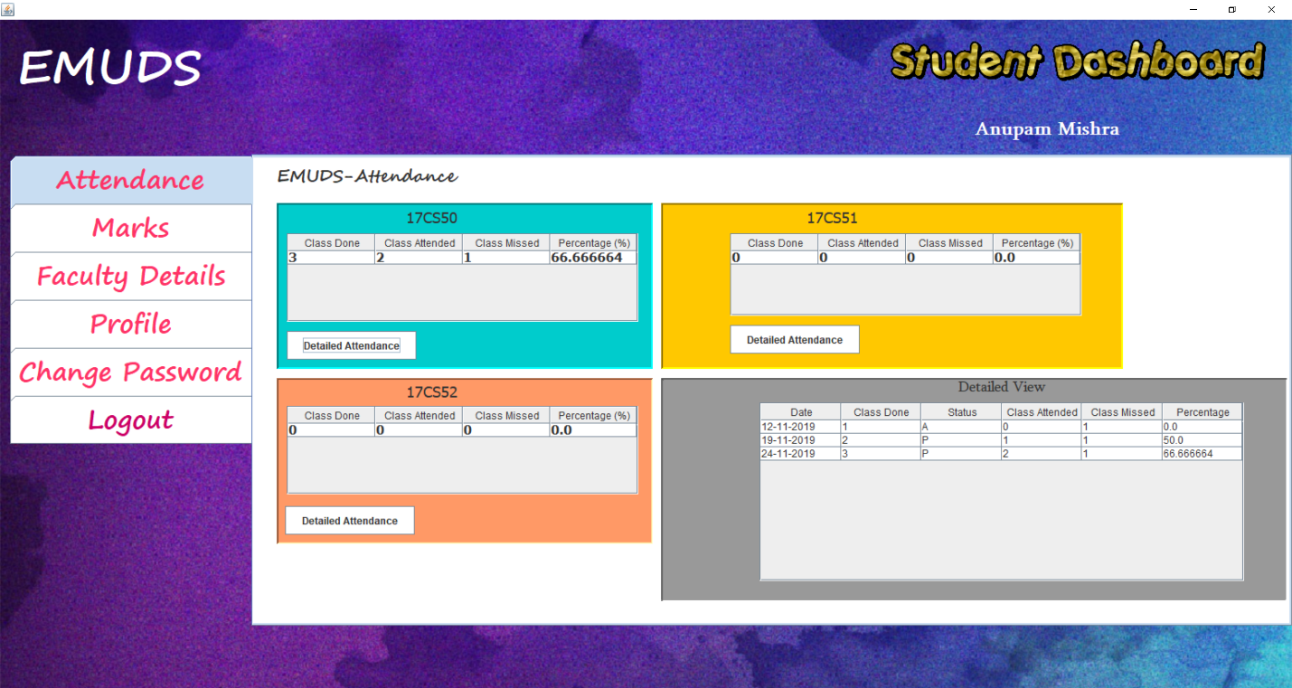

**Snapshot 20**: This panel shows the student the detailed day-to-day attendance of the selected subject .

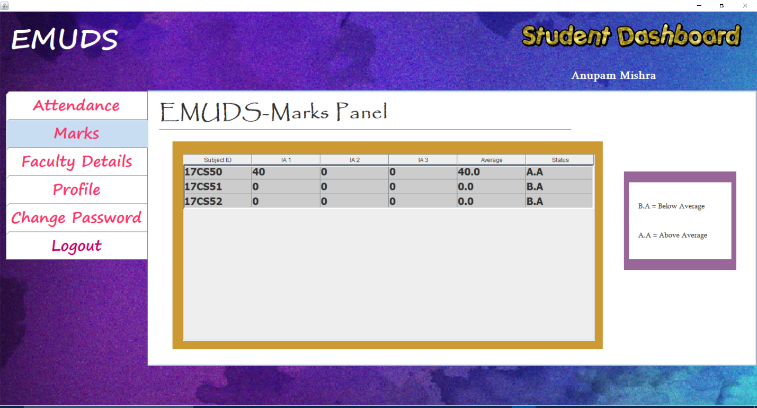

**Snapshot 21**: This panel shows the student their marks with average calculated and status of their marks.

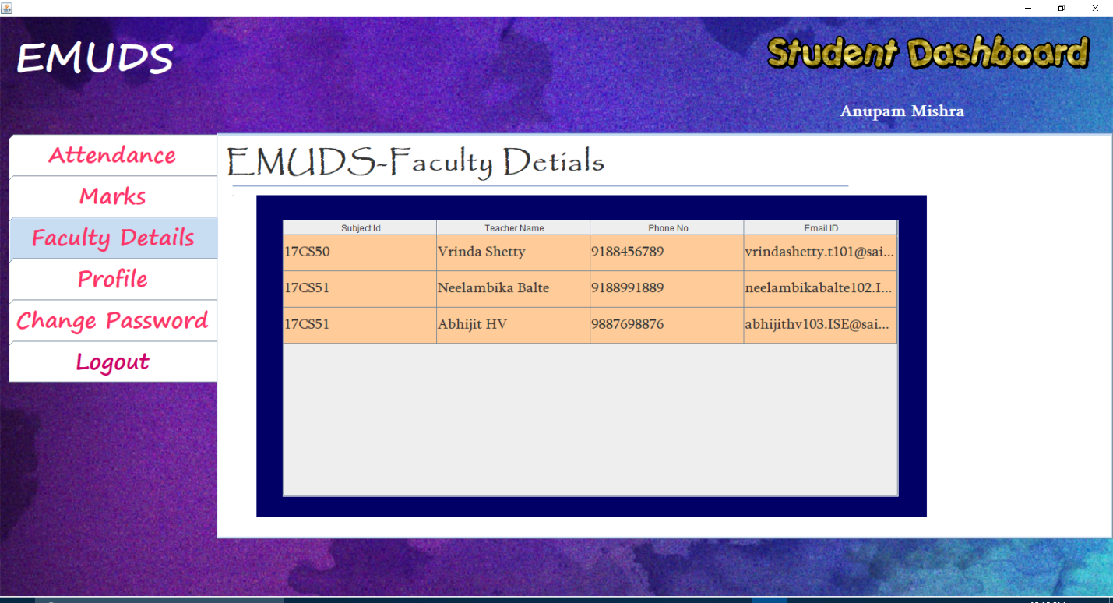

**Snapshot 22**: This panel gives the student their faculty details .

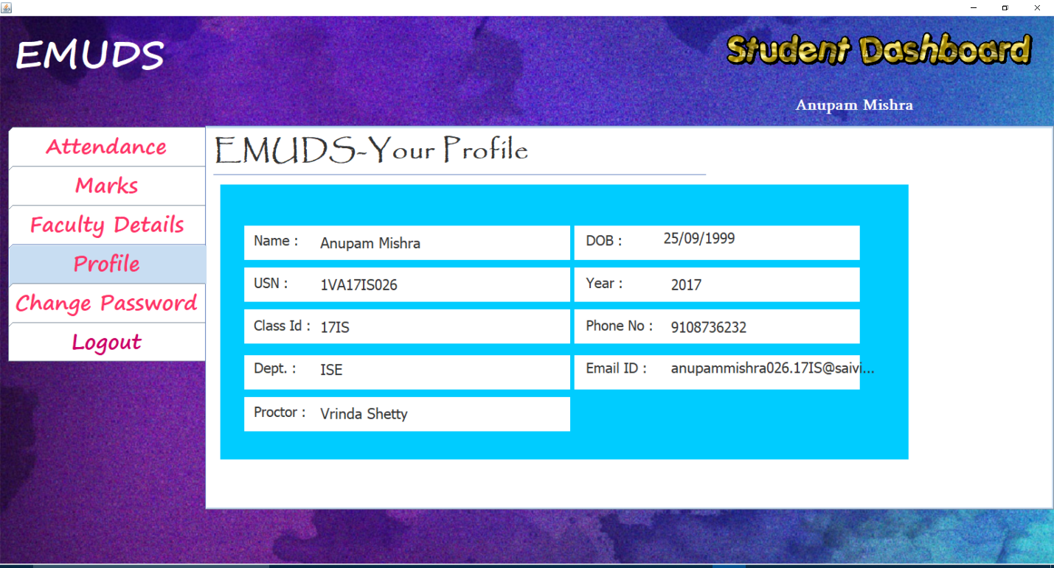

**Snapshot 23**: This panel shows the student their profile .

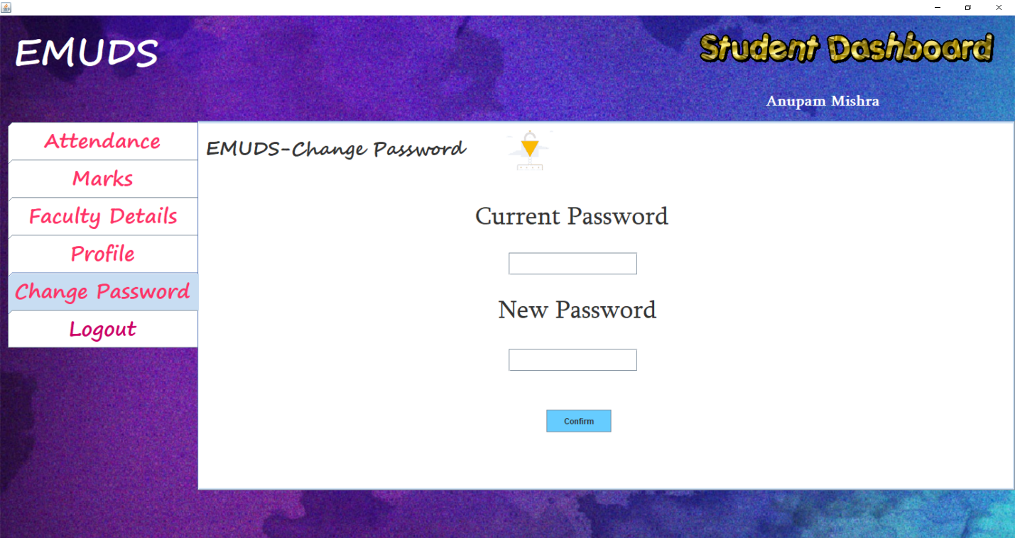

**Snapshot 24**: This panel gives the option for the students to change their password if needed.

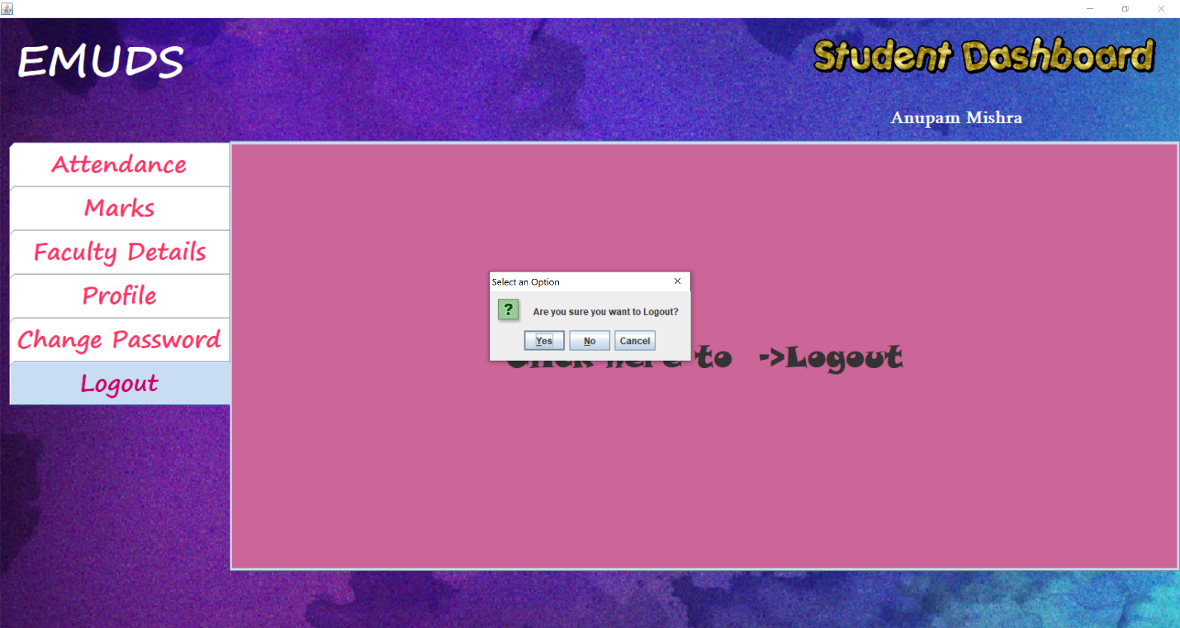

**Snapshot 25**: This panel gives the option to student to logout.

**CHAPTER 7**

**CONCLUSION**

The project EMUDS(College Department Management System) is successfully designed. The developed  project will be used in searching , retrieving and generating information  for the concerned requests.

A Student or a Teacher can login into EMUDS dashboard using the unique id and password. They can view there profile in the PROFILE TAB of the dashboard. A student can view his/her attendance and scored marks in the dashboard tabs defined for the same. A student/teacher can also change password from the dashboard if he/she wants to. A teacher can add or upload the scoring of his/her students on the EMUDS database using the teacher dashboard. A teacher can also mark the attendance of the students on daily basis by using the dashboard and can view the attendance from the same.Therefor EMUDS is a useful application/Software for the teachers as well as students which helps them managing their daily college activity.

The system comprises of following features:

* Marking of the attendance of teacher /students.
* Teacher/Student dash-Board controlling overall System.
* Uploading Marks of the students.
* Viewing of Attendance/Marks for the students.
* An Admin Panel for controlling the entire application.

**SCOPE OF ENHANCEMENT**

This EMUDS currently designed as a Desktop Application , which can be further developed as Web Application. In future one can also develop a advanced Mobile Application/Web Application for EMUDS with more improvised user experience and with extra features such as notification, alerts etc.

**BIBLIOGRAPHY**

**BOOK REFERENCE**

[1] Database System Models, Languages, Ramez Elmasri and Sham Kant B. Navathe, 7th Edition, 2017 Pearson.

**WEBSITES**

1. <https://stackoverflow.com/>
2. <https://www.geeksforgeeks.org/>
3. [www.youtube.com](http://www.youtube.com)
4. [www.google.com](http://www.google.com)
5. [www.pixabay.com (images)](http://www.pixabay.com(images))
6. [www.tenorgif.com(gif)](http://www.tenorgif.com(gif))